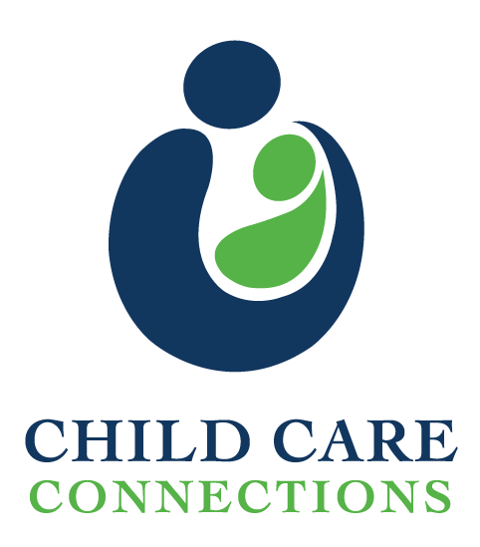
___________________________________________________________________________________________________

Please complete this form and return to Child Care Connections with payment of $35 made payable to Child Care Connections. Our mailing address is 1143 Stoneridge Drive Suite 1 Bozeman, MT 59718. You should receive a letter for the date you are registered for within 10 business days of submitting your registration. If you do not receive a letter, contact Kristy at 587-7786. Please feel free to call if you have any questions or need special arrangements.
Feel free to copy and re-use this form as needed.

Student Name: _________________________________Date of Birth____________________________
Parent Name: _______________________Mailing Address____________________________________
City___________________ State_________ Zip______ Best Contact Number_____________________ Allergies/Accommodations Needed________________________________________________________
I would like to receive my confirmation letter via:
Postal mail________ Email_________ (Please provide your email address)_______________________

In an effort to streamline the registration process, and due to the popularity of this class, please rank the classes of 2018 in the order in which you would like to be considered for a class. If the space is available your students will be placed in the class of first choice, and so on. Please note, it is possible for all classes to be filled for the year very early on, and space may not be available. There will not be a wait list for classes but in the event of a cancellation we will contact the next application that came in.

Each class is held 10am-3pm.
FULL January 20th, (Saturday) FULL February 10th, (Saturday)
_____ March 24th, (Saturday) _____April 21st, (Saturday)
_____May 19th, (Saturday)

We look forward to seeing you at our class! Due to the high demand for this class and the large volume of students turned away, we cannot refund or reschedule your child(ren) without a 24 hour advance notice of cancellation.
For Child Care Connections Staff Use Only:

Date Received: ___________ Cash / Check # ________________ Amount $__________

